**Experiment no 6**

Aim:- To implement star schema using SQL Server Management Studio.

Steps:-

Step1:-

Create a new database “data_modeling” through the SSMS and select the menu item

“Databases , data_modeling , Database Diagrams ,Install Diagram Support “. The menu

item wouldn’t appear if the diagram support feature were installed.

Step 2:-

Create a new Database Diagram and then go to programmability and under user defined data

types add the following keys:

• dbo.udt_item_key (int, not null)

• dbo.udt_branch_key (int, not null)

• dbo.udt_location_key (int, not null)

• dbo.udt_time_key (int, not null)

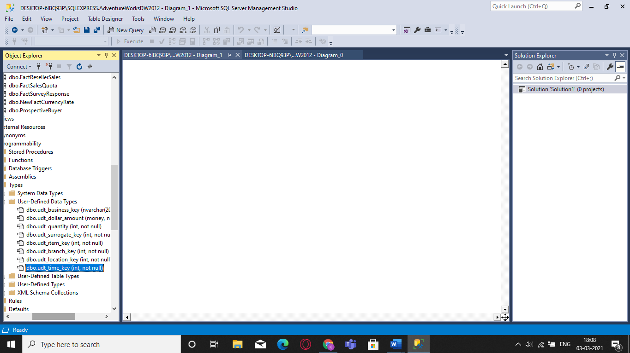

Step 3:-

Under the file database uploaded, go to tables option and right-click to create a new table

called dim_branch_table. (Please select the first data type inside each dimension table as

primary key)

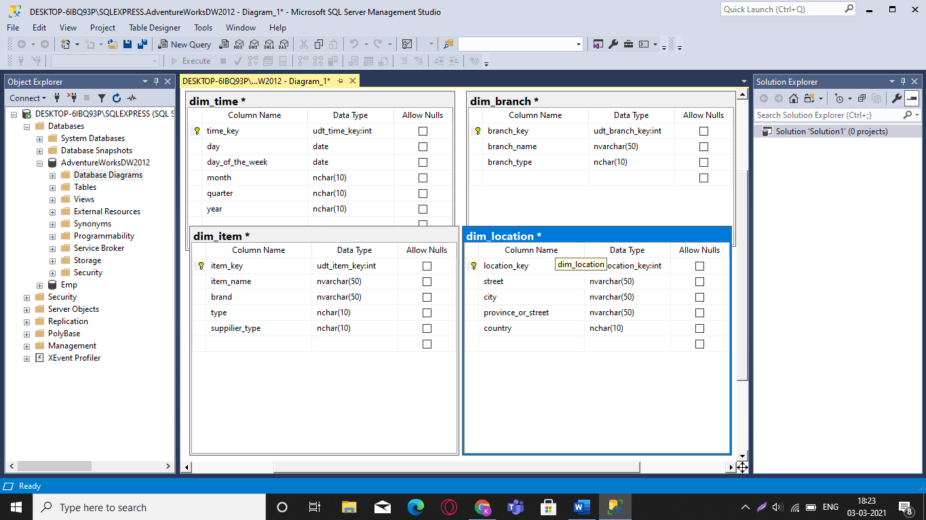

Create the following dimension tables with the appropriate data types:

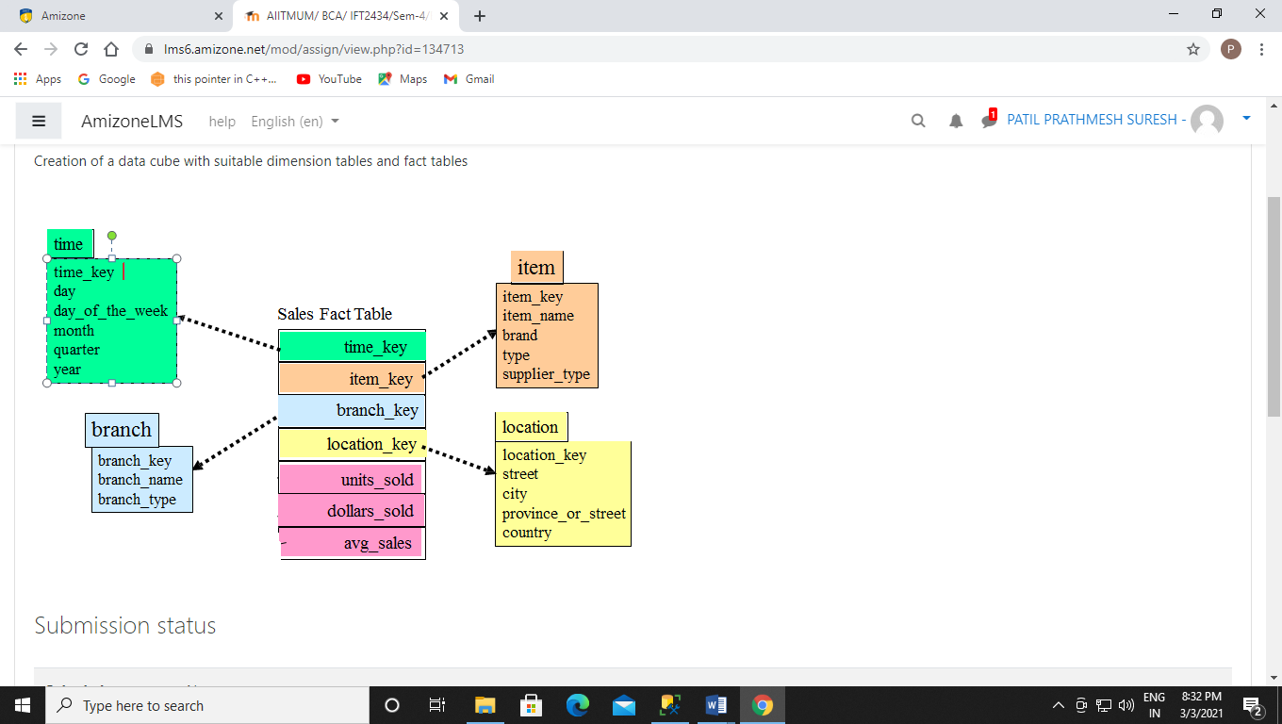

Step 5:-

Create a new table using the prior steps and name it “Sales_fact_table”. The table will have

the data types as given in the above image.

Save the design using “Cntrl+s” and the (*) sign should not be visible.

Step 6:-

Now drag each primary key from the dimension table to the appropriate fact table and there

should a solid line visible as a connection between them. Right click on the design and select

all and then inside view option select “name only”. Following that a star schema would be

visible. Please not to save the design after the star schema is visible.

